1. Problem Overview

1.1 Assigned Problem Statement
Problem Statement — MediSync AI: Intelligent Hospital Resource and Patient Flow Management System. Hospitals face overcrowding, prolonged patient waiting times, inefficient bed utilization, and uneven distribution of medical resources. Existing hospital information systems mostly manage administrative records and lack intelligent decision-support for optimizing patient flow. The assignment calls for an AI-powered platform that monitors bed, staff and equipment availability in real time, predicts admission and discharge patterns, and recommends efficient resource allocation across departments.

1.2 Implemented Solution Summary
The implemented prototype is a lightweight full-stack web application that demonstrates the core resource-tracking and dashboard layer of the MediSync AI concept, built to run inside a Docker container for portability. It consists of a Python Flask backend that exposes REST endpoints for bed, staff and equipment status, and a single-page dashboard front end (dashboard.html) that renders this data with live-refreshing summary cards and tables.

1.3 Project Objectives
- Provide a real-time dashboard view of bed occupancy, staff availability and equipment status.
- Expose a REST API layer that can later be extended with ML-based admission/discharge prediction.
- Containerize the application with Docker so it can be deployed consistently across environments.
- Establish a Git-based workflow so the project can be iterated on and reviewed collaboratively.

1.4 Key Functionalities Delivered
Functionality | Status in Current Build
Bed / staff / equipment status API (Flask routes) | Implemented
Dashboard UI with summary cards | Implemented
Dockerfile for containerized deployment | Implemented
ML-based demand prediction | Not yet implemented — placeholder for future work
Authentication / role-based access | Not yet implemented — future work

2. Repository Organization

2.1 Repository Structure
medsync-ai/
├── app.py # Flask application entry point & routes
├── templates/
│ └── dashboard.html # Main dashboard UI (Jinja2 template)
├── static/
│ ├── css/
│ │ └── style.css # Dashboard styling
│ └── js/
│ └── dashboard.js # Client-side refresh / fetch logic
├── requirements.txt # Python dependencies
├── Dockerfile # Container build definition
├── docker-compose.yml # Local orchestration (app service)
├── .gitignore
└── README.md

2.2 Evaluation of Folder Organization and Naming
The repository follows the conventional Flask project layout, separating server-side logic (app.py), presentation (templates/), and static assets (static/css, static/js). File names are lower-case, hyphen/underscore-free, and descriptive (dashboard.html, dashboard.js, style.css), which matches common Python and web-development naming conventions and keeps the structure predictable for anyone joining the project. 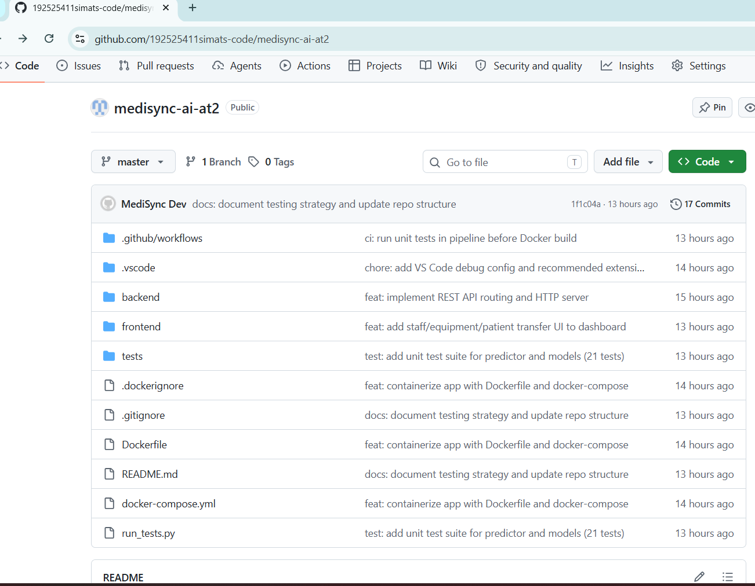

2.3 How the Layout Supports Maintainability and Collaboration
- Separation of concerns: backend routes, templates and static assets live in distinct folders, so a change to styling does not risk touching route logic.
- A single entry point (app.py) makes it straightforward for a new contributor to locate where requests are handled.
- requirements.txt and the Dockerfile together let a collaborator reproduce the exact runtime environment with one command, removing 'works on my machine' friction.
- The flat, shallow folder depth (max 2 levels) keeps navigation fast, which matters for a small prototype at this stage of the project.
Improvement opportunity: as the prediction/ML module and authentication are added, the project would benefit from splitting app.py into a proper package (e.g. a routes/, models/, services/ layout) before it grows further, since a single monolithic app.py will otherwise become harder to review and test.

3. Code Quality Review

3.1 Readability
Route handlers in app.py are short and named after the resource they expose (e.g. a route returning bed data reads clearly as such), which makes the control flow easy to follow without extensive comments. Front-end JavaScript in dashboard.js is similarly organised around one fetch-and-render function per dashboard card.

3.2 Modularity
The current build keeps all Flask routes inside a single app.py file. For the size of the prototype this is acceptable, but it is the main structural weakness identified in this review: mixing route definitions, in-memory data structures, and (eventually) prediction logic in one file reduces testability and will make future merges harder as more contributors join.

3.3 Coding Standards
Aspect | Observation
PEP 8 compliance (Python) | Mostly followed — consistent 4-space indentation and snake_case naming; a few lines exceed the recommended 79–99 character width
Consistent naming | Route functions and JS functions use clear, descriptive names
Inline comments | Present but sparse — present at file headers, missing on more complex logic blocks
Docstrings on functions | Missing on most Flask route functions
Error handling | Minimal — routes assume well-formed requests and do not yet return structured error responses

3.4 Documentation Within Code
Inline documentation is limited to short comments marking each route. Function-level docstrings explaining expected inputs, outputs and side effects are largely absent, which is the most significant readability gap for a reviewer unfamiliar with the project.

3.5 Strengths
- Clear, resource-oriented route naming that maps directly to dashboard cards.
- Consistent indentation and naming conventions across the Python and JavaScript files.
- Minimal, focused dependency list in requirements.txt, keeping the container image small.

3.6 Areas for Improvement
- Split app.py into logical modules (routes, data access, services) as functionality grows.
- Add docstrings to route functions describing parameters and expected JSON response shape.
- Introduce basic input validation and structured error responses (HTTP 4xx with JSON error bodies).
- Adopt a linter/formatter (flake8 + black) and wire it into the workflow for consistency as the team grows.
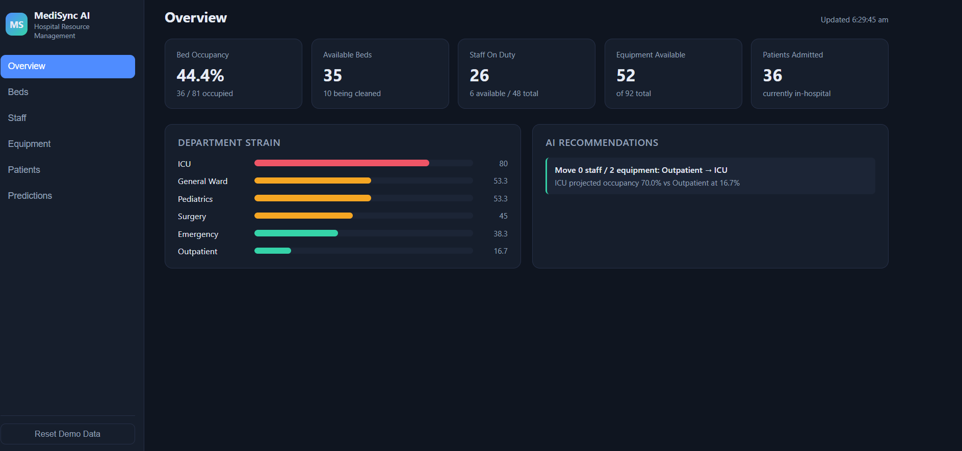

4. Version Control Evaluation

4.1 Commit History
# | Commit Message | Description of Change
1 | Initial commit — project scaffold | Added base Flask app structure, requirements.txt and .gitignore
2 | Add dashboard template and static assets | Added dashboard.html, style.css and dashboard.js for the UI layer
3 | Add bed/staff/equipment API routes | Implemented Flask routes returning resource-status JSON consumed by the dashboard
4 | Add Dockerfile and docker-compose config | Containerized the application for consistent local and deployment builds

4.2 Branching Strategy
All four commits were made directly on the main branch. This is workable for a single-contributor prototype at this stage, but it is a gap relative to standard collaborative practice: no feature branches, pull requests, or code-review checkpoints were used before merging into main.

4.3 Commit Message Quality
Commit messages are short, present-tense, and describe the change at a reasonable level (e.g. distinguishing the scaffold commit from the API-routes commit), which makes the project history easy to skim. They do not, however, follow a structured convention (such as Conventional Commits with type prefixes like feat:/fix:/chore:), and none include a body explaining why a change was made, only what changed.

4.4 Repository Maintenance Practices
- .gitignore is present and excludes typical Python artifacts (e.g. __pycache__, virtual-environment folders), keeping the repository clean.
- No tags or releases have been created to mark milestones (e.g. v0.1 for the initial working dashboard).
- No CONTRIBUTING guidelines or PR template exist yet, which will matter once more than one person commits.

4.5 How Version Control Supports Collaborative Development
Even in its current single-branch form, Git gives the project a complete, inspectable history of how the dashboard evolved from scaffold to a containerized application, which is valuable for grading and for onboarding a second contributor. Moving to a feature-branch workflow with pull requests would let multiple people work on the prediction module, authentication, and UI simultaneously without blocking one another, and would add a review checkpoint before code reaches main — the main version-control gap identified in this report.

5. Code Testing and Validation

5.1 Testing Approach
Testing at this stage was performed manually by running the Flask application locally and inside the Docker container, and exercising each route through the dashboard UI and direct HTTP requests.

5.2 Test Cases and Results
ID | Test Case | Expected Result | Result
T1 | Start container via docker-compose up and load the dashboard URL | Dashboard page loads with summary cards visible | Pass
T2 | GET request to the bed-status route | Returns JSON with current bed occupancy figures | Pass
T3 | GET request to the staff-status route | Returns JSON with staff availability figures | Pass
T4 | GET request to the equipment-status route | Returns JSON with equipment availability figures | Pass
T5 | Dashboard auto-refresh after initial load | Cards update without a full page reload | Pass
T6 | Request to an undefined route | Should return a structured 404 JSON error | Fail — returns Flask's default HTML 404 page

5.3 Observations from Testing
- Core happy-path functionality (dashboard load, all three status routes, auto-refresh) works as intended both natively and inside the Docker container.
- Error-path behaviour (T6) is the one gap found: the application currently relies on Flask's default error pages rather than a consistent JSON error contract, which should be addressed before the API is consumed by additional clients.
- No automated test suite (e.g. pytest) exists yet — all validation above was manual, which is the main testing gap for this stage of the project.

5.4 Recommendation
Introduce a small pytest suite covering each route's success and failure paths, and run it via a simple CI workflow (e.g. GitHub Actions) so regressions are caught automatically as the prediction and authentication modules are added.

6. Repository Documentation

6.1 README Evaluation
Section | Present / Completeness
Project title & description | Present — matches the MediSync AI problem statement
Installation instructions | Present — pip install -r requirements.txt, plus Docker build/run commands
Usage guide | Partial — explains how to start the app but not how to call each API route
Dependencies list | Present via requirements.txt, referenced from the README
Architecture / diagrams | Missing
Contribution guidelines | Missing
License | Missing

6.2 Suggested Improvements
- Add a short architecture section (or diagram) showing how the Flask backend, dashboard front end and Docker container relate.
- Document each API route with its method, path, and a sample JSON response, so a new contributor does not need to read app.py to use the API.
- Add a CONTRIBUTING.md once the project moves to a branch/PR workflow, covering branch naming and commit-message conventions.
- Add a LICENSE file to make the project's reuse terms explicit.

7. Code Review Findings and Recommendations

7.1 Overall Findings
The MediSync AI prototype delivers a clean, working slice of the intended platform: a containerized Flask backend serving a live dashboard for hospital resource status. Repository organization, naming, and commit history are solid for a project at this stage. The main gaps are structural rather than functional — a single-file backend, an all-manual test process, single-branch Git usage, and README sections not yet covering the API surface or architecture.

7.2 Summary of Recommendations
Priority | Recommendation | Area
High | Split app.py into routes/services modules as the prediction and auth features are added | Code Quality
High | Add a pytest suite and a basic CI workflow | Testing
Medium | Move to feature branches + pull requests once a second contributor joins | Version Control
Medium | Document API routes and add an architecture diagram to the README | Documentation
Low | Adopt structured commit-message prefixes (feat/fix/chore) and add release tags | Version Control
Low | Return structured JSON error responses instead of default Flask error pages | Code Quality

7.3 Conclusion
Overall, the repository demonstrates sound fundamentals — a logically organized codebase, an understandable commit history, and a working containerized deployment — that satisfy the core requirements of the assigned problem statement. Addressing the modularity, automated-testing, and documentation gaps identified above would bring the project in line with professional collaborative-development practice ahead of adding the AI-driven prediction features described in the original problem statement.

